Software Requirements Specification for

Restaurant Seating System

Version 1.0 approved

Prepared by

Alex McCarthy, Charles Lyding, Azeb Kieda, Dorothy Benton

October 23, 2017

Table of Contents

Table of Contents........................................................................................................................... ii

Revision History............................................................................................................................. ii

1.   Introduction.............................................................................................................................. 1

1.1   Purpose................................................................................................................................. 1

1.2   Document Conventions........................................................................................................ 1

1.3   Intended Audience and Reading Suggestions........................................................................ 1

1.4   Product Scope....................................................................................................................... 1

1.5   References............................................................................................................................ 1

2.   Overall Description.................................................................................................................. 2

2.1   Product Perspective.............................................................................................................. 2

2.2   Product Functions................................................................................................................. 2

2.3   User Classes and Characteristics........................................................................................... 2

2.4   Operating Environment......................................................................................................... 2

2.5   Design and Implementation Constraints................................................................................ 2

2.6   User Documentation............................................................................................................. 2

2.7   Assumptions and Dependencies........................................................................................... 3

3.   External Interface Requirements........................................................................................... 3

3.1   User Interfaces..................................................................................................................... 3

3.2   Hardware Interfaces............................................................................................................. 3

3.3   Software Interfaces............................................................................................................... 3

3.4   Communications Interfaces.................................................................................................. 3

4.   System Features....................................................................................................................... 4

4.1   System Feature 1.................................................................................................................. 4

4.2   System Feature 2 (and so on)................................................................................................ 4

5.   Other Nonfunctional Requirements....................................................................................... 4

5.1   Performance Requirements................................................................................................... 4

5.2   Safety Requirements............................................................................................................. 5

5.3   Security Requirements.......................................................................................................... 5

5.4   Software Quality Attributes.................................................................................................. 5

5.5   Business Rules...................................................................................................................... 5

6.   Other Requirements................................................................................................................ 5

Appendix A: Glossary................................................................................................................... 5

Appendix B: Analysis Models....................................................................................................... 5

Appendix C: To Be Determined List........................................................................................... 6

Revision History

|  |  |  |  |
| --- | --- | --- | --- |
| **Name** | **Date** | **Reason For Changes** | **Version** |
|  |  |  |  |
|  |  |  |  |

**1.** **Introduction**

**1.1** **Purpose**

The purpose of this document is explain describe the Restaurant Seating System. It will explain the purpose and functionality of each of the features of the program as well as the constraints of the system. This document is intended for both the customers and the programmers.

**1.2** **Document Conventions**

User: Entity that would be interacting with the software product

Software/Product : The final product being delivered to customer(Krusty Krab Restaurant Seater)

This document follows standard MLA format.

**1.3** **Intended Audience and Reading Suggestions**

This document is intended for the development team, beta testers and the customer. This document is organized in a order to understand the product better.

Overall Description: The development team is able to understand how the software operated so the programmers can get clear idea of the project. The customer can get a better understanding of the development process and confirm that the product is what the customer asked for.

External Requirements: The development team is able to understand what external requirements are required to build this product

System Features: The development team is able to understand what features are necessary to build this product. Testers should also understand the features to develop test cases.

Non Functional Requirements: The development team should be able to understand what non functional requirements are in place.

**1.4** **Product Scope**

This product contains the development of an algorithm to keep track of reservations, current guests, seats, parties and servers at execution time. An Graphical User Interface for the Restaurant Seater is also included. The algorithm will communicate with the graphical user interface so the user can get a visual diagram of the operation.

**1.5** **References**

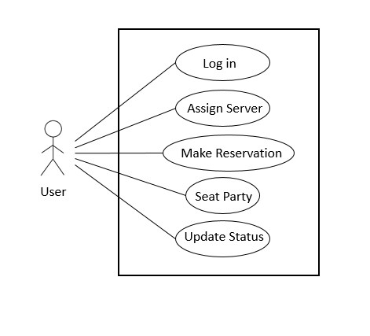

Figure 1. Use case diagram for restaurant seating system.

**2.** **Overall Description**

**2.1** **Product Perspective**

This product is a stand-alone, self-contained program.  A customer (restaurant) does not need any previous program in place and does not need to connect to any other systems.  This program will most likely replace a pen-and-paper strategy for selecting and managing tables.

**2.2** **Product Functions**

* The program shall be able to display a start page with login, username and password text fields.
* The user shall be able to log in by using user-name and password.
* The program shall be able to display reserved and unreserved tables, servers’ names with their tables list and how many customers each table have.
* The user shall be able to make the reservation by putting the customer’s information.
* After the reservation the system shall be able to assign a table to the customer and the server.

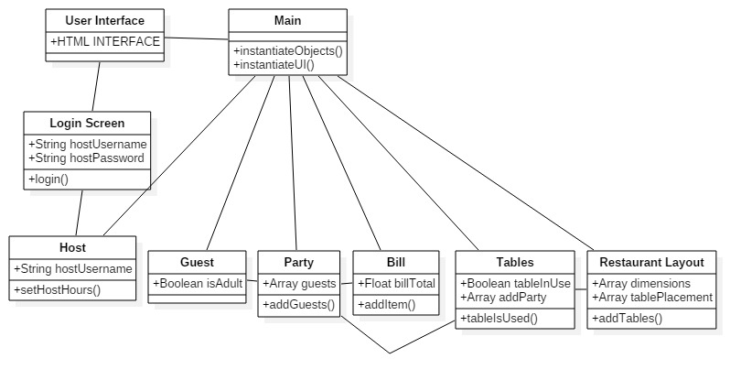

Figure 2. Class diagram for restaurant seating system

**2.3** **User Classes and Characteristics**

2.3.1. Host:

           The host at the restaurant use the system frequently. The host isn’t expected to have any high educational, long time experience with the system or technical expertise. They don’t have any security or privilege levels. The system is easy to follow and easy to use in general.

2.3.2. DBA:

          The DBA is expected to have a college degree or seven years of equivalent experience in the specific  IT field. He/She has the privilege levels of updating information and securing the system. They don’t have directly interaction with the system.

**2.4** **Operating Environment**

The software will be running on an Oracle Java 7.0 environment. The software will be run in an environment with a graphical user interface consisting text fields, icons, and buttons. The hardware running this software will be any desktop or portable device capable of running Java.

**2.5** **Design and Implementation Constraints  (Optional)**

**2.6** **User Documentation**

The program will come with a user manual.  This manual will explain the different functionalities of the program and will include examples.

**2.7** **Assumptions and Dependencies**

One assumption about the software is that it is intended to be run on machines that support java.

Another assumption about the software is that it is a graphic intense software. There maybe scenarios where the performance is poor if the machine running the software does not have the recourses to run the software.

**3.** **External Interface Requirements**

**3.1** **User Interfaces**

Users will be able to log in to the program using their own username and password. After logging in, users will see a layout of their restaurant.

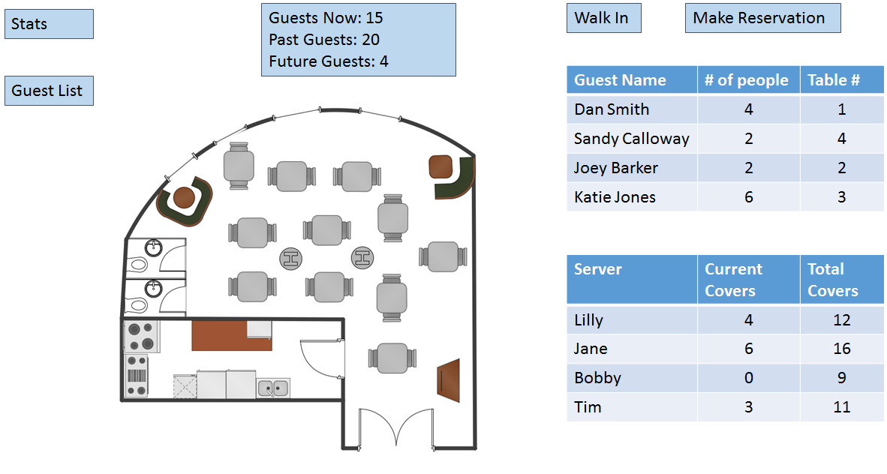

Figure 3. Example of a user screen.

**3.2** **Hardware Interfaces (Optional)**

**3.3** **Software Interfaces**

The system shall communicate with the graphical interface to provide a friendly graphical user interface for the user.

Not Applicable.

**3.4** **Communications Interfaces**

Not Applicable.

**4.** **System Features**

**4.1** **Display**

4.1.1   Description and Priority

4.1.1 The System shall display a user interface for the client to see the upcoming reservations, available tables, unavailable tables, guest names, people per table, and statistics of current room behavior. Priority level of “Display” is 9. Benefits the client by giving the client a visual diagram of what kind of interaction is going on with each table and what is upcoming throughout the service hours.

4.1.2   Stimulus/Response Sequences

4.1.2 Stimulus/Response Sequences

-User starts the program

-User will log in.

-User is greeted with display

4.1.3   Functional Requirements

FR-1 The system shall provide a graphical user interface so that when the program is launched, the user is greeted by a graphical diagram of the restaurant.

FR-2 The system shall provide the user a  graphical interface to show the users the upcoming reservation guests depicted as a table

FR-3 The system shall provide the user a graphical display of which tables are available.

FR-3.1 The system shall provide the user a graphical display of which tables are unavailable.

FR-4 The system shall provide the user a graphical display of guests at current table(if exists)

FR-4.1  The system shall provide the user a graphical display number of  guests currently at a table(if exists)

**4.2 Login**

4.1.1 Description and Priority

The system shall allow the user to login with credentials to have authorization to use the program. The priority level of “Login”  is 9. The benefit of “Login” is that it grants the user access to use the program.

4.1.2

-User starts the program

-User is greeted with empty text fields

-User is types in credentials

-User hits login button

-User is granted or denied access

4.1.3 Functional Requirements

FR-1 The system shall greet the user with empty text fields that allow the user to type in their login credentials

Fr-2 The system shall provide a button that allows the user to authenticate their credentials.

Fr-3 The system shall provide a authenticator which authenticates the user’s credentials which then grants the user access if the credentials are valid

Fr-3.1 The system shall provide a authenticator which authenticates the user’s credentials which then denies the user access if the credentials are invalid

**4.3** **Assign Server to Table**

4.3.1 Description and Priority

The system shall allow the user to select a table the user desires to serve. As a result, the user’s name which is represented as the server name will be assigned to a table object in the program.

4.3.2 Stimulus/Response Sequences

* User selects tables
* User confirms selecting table
* User confirmed as server for table that is selected

4.3.3 Functional Requirements

* FR 1 The system shall allow the user select the table(s) the user desires to be selected as the server
* FR 1.2 The system shall allow the user confirm the table the user desires to serve
* FR 1.3 The system shall check if the table is available for server to serve
* FR 1.3.2 The system shall check if the table is unavailable for server to serve
* FR 2 The system shall assign the user to table the user desires to serve

**4.4** **Make Reservation**

4.4.1   Description and Priority

The system will allow the user to make a new reservation using a guest’s name, the number of people in the party, the time they will arrive, and any special requests.  Priority level of “Make Reservation” is 8.  Benefits of “Make Reservation” include: allowing users to keep track of who will be coming into the restaurant and predict what times will be the busiest.

4.4.2   Stimulus/Response Sequences

* User will select “Make Reservation” button.
* System will present reservation screen with text fields available for user input
  + Guest name
  + Number in party
  + Reservation time
  + Table number
  + Special requests
* User will select “Save”
* System will add guest to reservation list.

4.4.3   Functional Requirements

FR-1 The system shall display a graphical user interface that allows the user to select the “Make Reservation” feature.

FR-2 The system shall display a user interface that allows the user to input guest data.

FR-3 The system shall use the guest data entered by the user to create a “party” object that can be assigned to a table within the restaurant.

**4.5** **Seat Party**

4.5.1   Description and Priority

The system will allow the user to seat parties at their assigned table once they arrive at the restaurant.  This will remove the party from the reservation list. Priority level of “Seat Party” is 8.  The benefit of “Seat Party” is allowing the user to keep track of who has arrived for their reservation and where they are located within the restaurant.

4.5.2   Stimulus/Response Sequences

* System will display reservation list
* User will select a party from the reservation list
* User will select “Seat” button
* System will remove party from the reservation list
* System will mark selected table as occupied
* System will display the updated server cover  count based on party size

4.5.3   Functional Requirements

FR-1 The system shall display all reservations that have not yet arrived.

FR-2 The system shall remove selected party from reservation list.

FR-3 The system shall add the selected party to the table object associated with the assigned table number.

FR-4 The system shall update the cover count of the server assigned to the selected table using the designated party size.

**4.6** **Update Status**

4.6.1   Description and Priority

The system will allow the user to update the status of tables in the restaurant.

Possible statuses include:

* Seated
* Placed Order
* Received Food
* Received Check
* Bussing
* Clean

Priority level of “Update Status” is 5.  The benefit of “Update Status” is allowing users to keep track of what certain parties are doing in the restaurant. With this feature, users will be able to better estimate how long each party will be at a table.

4.6.2   Stimulus/Response Sequences

* System will display restaurant floor plan indicating which tables are seated
* User will select a table to update
* System will display available statuses
* User will select the current status of the table
* System will display current status of table on floor plan

4.6.3   Functional Requirements

FR-1 The system shall display the status of all tables in the restaurant using color-coding

FR-2 The system shall allow users to select tables to update

FR-3 The system shall display a list of available statuses

FR-4 The system shall update the table selected by the user to the selected status

**5.** **Other Nonfunctional Requirements**

**5.1**     **Performance Requirements**

The Krusty Krab Restaurant System will perform better when run on a high speed internet connection.

The System will also perform better when the physical machine of the user has the latest version of Java.

The System will perform better if the physical machine contains a graphics card Nvidia Geforce GTX 1050 or AMD Radeon RDX 550 and beyond.

The System will perform better if the physical machine contains a processor from ntel Core i3-6100 , AMD A10-7860K and beyond.

**5.2** **Safety Requirements**

The Krusty Krab Restaurant will contain a list of users who are able to be granted into the system. Any user who is not on the list will have to be whitelisted and added to prevent any unauthorized access.

**5.3** **Security Requirements**

The Krusty Krab Restaurant server will have its own security measures to prevent any unauthorized reservations, server assignment and seating. Only users who are granted access to the program through the login page will have the ability to change the situation of the restaurant. Any users who do not have the correct credentials will not be granted access.

**5.4** **Software Quality Attributes**

Not Applicable.

**5.5** **Business Rules**

Not Applicable

**6.** **Other Requirements**

Appendix A: Glossary

|  |  |
| --- | --- |
| User | Any restaurant employee (host, manager, etc) who would need to see guest information |
| Covers | Number of customers assigned to each server |
| Party | Group of customers sitting together at the same table |

Appendix B: Analysis Models

Appendix C: To Be Determined List